Year 1/2 Long Term Overview – A
Persuade Inform Entertain Discuss
Autumn 1 | Autumn 2 | Spring 1 | Spring 2 | Summer 1 | Summer 2
Learning Journey 1 | Learning Journey 1 | Learning Journey 1 | Learning Journey 1 | Learning Journey 1 | Learning Journey 1
Text:  Red in the City  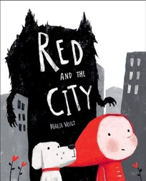  Outcomes:  Description of the wolf  Retelling with a twist | Text: Meerkat Mail  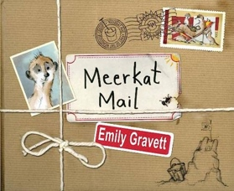  Outcome:  Postcard | Text: Big Bear Little Brother  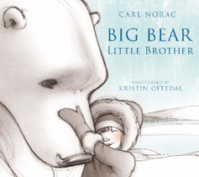  SOA:  Description  Outcome:  Diary | Text:  The Day The Crayons Quit  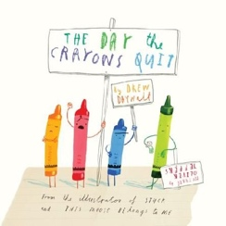  Outcome:  Letter | Text:  Traction Man  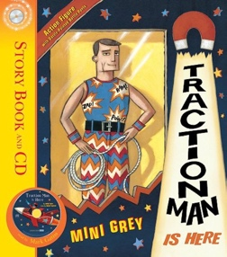  SOA: May Day writing  Outcomes:  Story  Character Description | Text: The Most Important Animal of All  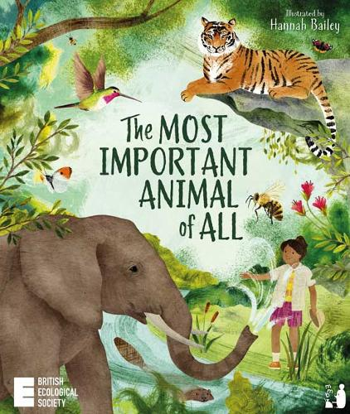  Outcome:  A letter to teacher  Writing Skills  Revise all skills this year/ grammar revision
Writing Skills  - Compose a sentence orally before writing it (Year 1)  - Begin to punctuate sentences using a capital letter and a full stop (Year 1)  - Use capital letter for names (Year 1)  Use expanded noun phrases  Reading Skills  Explain clearly their understanding of what is read to them (Year 1)  Discuss the sequence of events in books and how items of information are related  becoming very familiar with key stories, fairy stories and traditional tales, retelling them and considering their particular characteristics | Writing Skills  the personal pronoun ‘I  using question marks | Writing Skills  - Sequence sentences to form short narratives (Year 1)  - When planning, write down ideas and/or key words, including new vocabulary (Year 2)  - Use –ed, where no change is needed in the spelling of root words (Year 1)  - Use the past tenses correctly and consistently (Year 2)  - Spell common exception words (Year 1)  - Spell more words with contracted forms (Year 2)  - the personal pronoun ‘I  Reading skills  - Make inferences on the basis of what is being said and done (Year 1 and Year 2)  - Answer questions (Year 2)  - Discuss the sequence of events in books (Year 2)  Discuss the significance of the title and events (Year 1) | Writing Skills  - Use subordination (Y2)  - using the prefix un– (I am unhappy etc)  - using er and -est  - possessive apostrophe’s (Y2) | Writing Skills  using –ing  exclamation marks  adverbs – ly (Y2)
Learning Journey 2 | Learning Journey 2 | Learning Journey 2 | Learning Journey 2 | Learning Journey 2
Text: Rapunzel, Bethan Woollvin  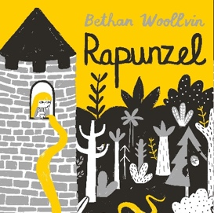  SOA:  Character description of Rapunzel  Outcome:  Retelling of the story | Text: Snow, Walter De la Mare  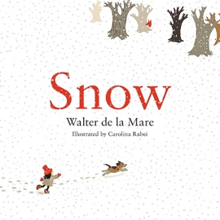  SOA:  Fact file about Winter  Outcome:  Write their own Winter poem | Text: The Queen's Hat, Steve Antony  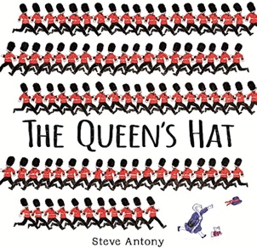  SOA:  First person diary  Outcome:  Narrative - immitate | Text:  Africa, Amazing Africa  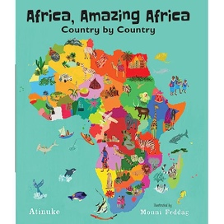  SOA:  Description of an African animal  Outcome:  Report about an African country | Complete some extra star writes during this time as evidence for Y2 writers.  Y1 to also complete SPAG revision activities and common exception word test
Writing Skills  - Compose a sentence orally before writing it (Year 1)  - Begin to punctuate sentences using a capital letter and a full stop (Year 1)  - Use capital letter for names (Year 1)  - Use coordinating conjunctions (or/and/but) (Year 2)  - Use the present and past tenses correctly and consistently (Year 2)  Reading skills  - Explain clearly their understanding of what is read to them (Year 1)  - Explain and discuss their understanding of books, poems, and other material, both those that they listen to and those that they read for themselves (Year 2)  Discuss the sequence of events in books and how items of information are related (Year 2)  becoming very familiar with key stories, fairy stories and traditional tales, retelling them and considering their particular characteristics | Writing Skills  Use -es and -s for plural endings (Year 1)  Use -ing for words that don’t require changing the root word  Writing poetry (Year 2)  Reading Skills  Ask questions about a text  Discuss favourite words and phrases  Discuss expressing views about a wide range of contemporary and classic poetry (Year 2)  Answer questions (Year 2) Discuss the significance of the title and events (Year 1)  learning to appreciate rhymes and poems, and to recite some by heart (Year 1) | Writing Skills  - Write simple narratives (Y2)  - Use subordination (Y2)  - Sequencing sentences to form short narratives (Y1)  - Use capital letters for the names of places  Reading:  - Make inferences (Y2)  - Make a plausible prediction (Y2)  - Make links with other books they have read (Y2)  - Make links with what they have read to their own experiences (Y1)  - Make inferences based on what is said and done (Y1) | Writing Skills  - Use capital letters for the names of places  statements/  questions/exclamations  - And
Ongoing writing skills

- writing narratives about personal experiences and those of others (real and fictional)
- writing about real events
- writing poetry
- writing for different purposes
- planning or saying out loud what they are going to write about • writing down ideas and/or key words, including new vocabulary • encapsulating what they want to say, sentence by sentence
- evaluating their writing with the teacher and other pupils
- re-reading to check that their writing makes sense and that verbs to indicate time are used correctly and consistently, including verbs in the continuous form
- proof-reading to check for errors in spelling, grammar and punctuation [for example, ends of sentences punctuated correctly]
- read aloud what they have written with appropriate intonation to make the meaning clear.
- segmenting spoken words into phonemes and representing these by graphemes, spelling many correctly
- learning to spell common exception words
- learning to spell more words with contracted forms

Ongoing reading skills
- listening to, discussing and expressing views about a wide range of contemporary and classic poetry, stories and non-fiction at a level beyond that at which they can read independently
- discussing the sequence of events in books and how items of information are related
- becoming increasingly familiar with and retelling a wider range of stories, fairy stories and traditional tales
- eing introduced to non-fiction books that are structured in different ways
- recognising simple recurring literary language in stories and poetry
- discussing and clarifying the meanings of words, linking new meanings to known vocabulary
- discussing their favourite words and phrases

